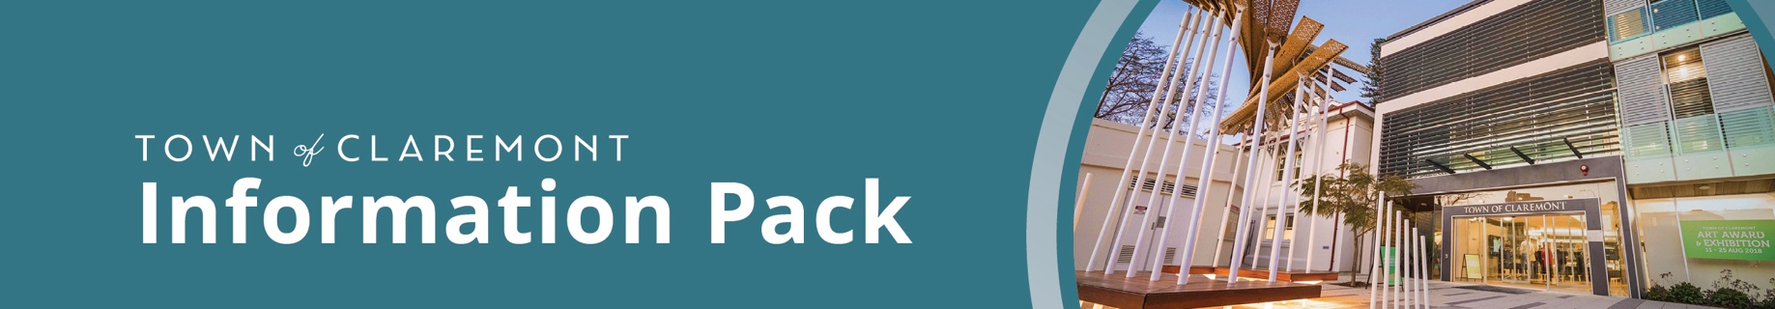
Call for Volunteers - Museum Education Volunteer

The Town of Claremont is seeking an enthusiastic volunteer, ideally a former educator, trainee teacher, or experienced presenter, to bring local history to life for primary school students at the Claremont Museum. Through interactive learning experiences, you will help children explore domestic life in 19th-century Australia and develop an appreciation for local heritage.
Key Tasks
- Lead small groups of primary school students in hands-on activities, including traditional cooking, heritage washing, and period classroom lessons.
- Facilitate engaging, age-appropriate group discussions.
- Support museum staff in maintaining a safe, welcoming environment for visiting schools.
Commitment & Requirements
- Time Commitment: Approximately 2 hours per week, running on Mondays and Tuesdays during school Terms 2 and 3.
- Requirements: A valid Working with Children Check (or the ability to obtain one).
Established in 1898, the Town of Claremont serves the picturesque riverside suburbs of Claremont and Swanbourne. A forward-focused local government with dedicated staff, the Town was recently ranked the Number 1 local government in the Community Scorecard survey.
To apply, select "Apply Now" or email your application to TOC@Claremont.wa.gov.au. For enquiries, please contact the Human Resources team on (08) 9285 4300.

